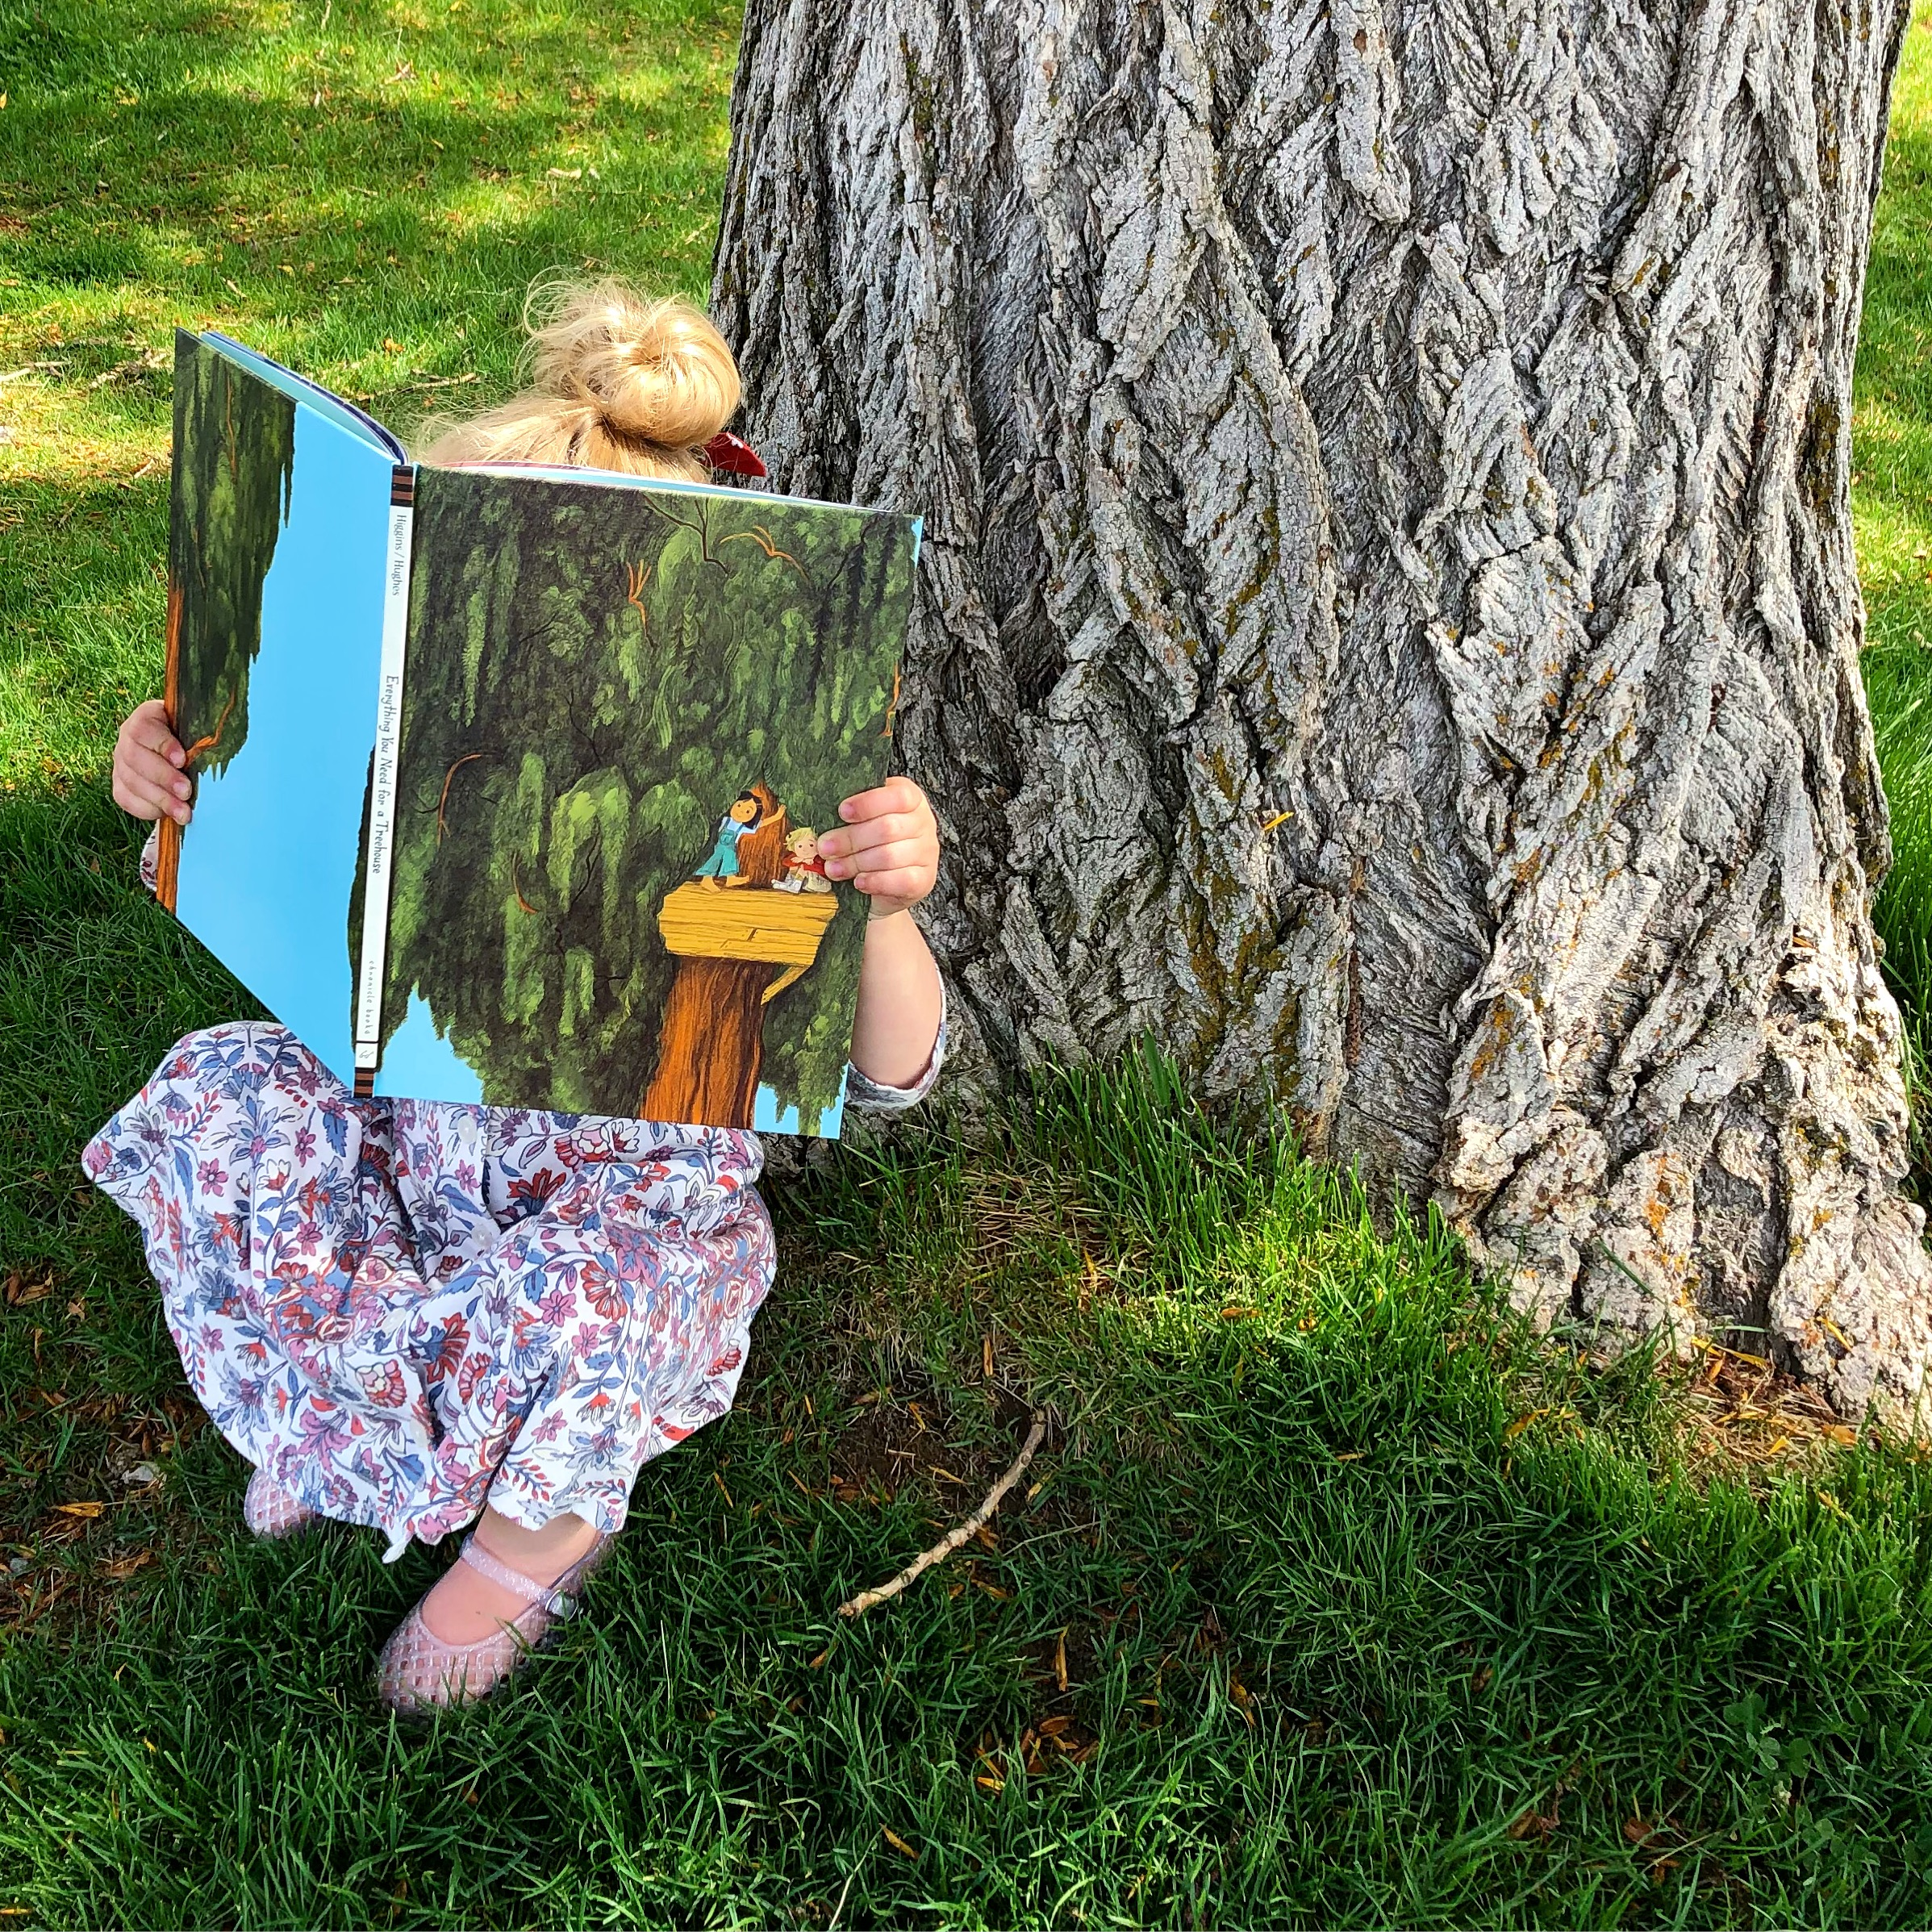
100 Picture Books
For Your
Summer Reading
- “It Came In the Mail” by Ben Clanton
www.booknerdmommy.com
- “Parts” by Tedd Arnold
- “I Wanna Be a Cowgirl” by Angela DiTerlizzi and Elizabet Vukovic
- “If You Give a Moose a Muffin” by Laura Numeroff and Felicia Bond
- “Pen Pals” by Alexandra Pichard
- “Froggy Bakes a Cake” by Jonathan London and Frank Remkiewicz
- “Pig the Pug” by Aaron Blabey
- “A Color Of His Own” by Leo Lionni
- “Goodnight Everyone” by Chris Haughton
- “Sleep Tight Farm” by Eugenie Doyle and Becca Stadtlander
- “The Wish Tree” by Kyo Maclear and Chris Turnham
- “The Dot” by Peter H. Reynolds
- “Dragon Was Terrible” by Kelly DiPucchio and Greg Pizzoli
- “The Pencil” by Allan Ahlberg and Bruce Ingman
- “Hedgehugs and the Hattipillar” by Steve Wilson and Lucy Tapper
- “Grandma’s Gloves” by Cecil Castellucci and Julia Denos
- “Dot In the Snow” by Corrinne Averiss and Fiona Woodcock
- “Just Go to Bed!” by Mercer Mayer
- “If I Had a Dinosaur” by Gabby Dawnay and Alex Barrow
- “The House in the Night” by Susan Marie Swanson and Beth Krommes
- “A River” by Marc Martin
- “Goodnight Moon” by Margaret Wise Brown and Clement Hurd
- “Little Big Girl” by Claire Keane
- “A Small Thing But Big” by Tony Johnston and Hadley Hooper
- “If I Had a Little Dream” by Nina Laden and Melissa Castrillon
- “Kittens First Full Moon” by Kevin Henkes
- “Little Blue Chair” by Cary Fagan and Madeline Kloepper
- “Charlotte and The Rock” by Stephen W. Martin and Samantha Cotterill
- “Charlotte The Scientist is Squished” by Camille Andros and Brianne Farley
- “Triangle” by Mac Barnett and Jon Klassen
- “Mighty, Mighty Construction Site” by Sherri Duskey Rinker and Tom Lichtenheld
- “Noisy Night” by Mac Barnett and Brian Biggs
- “Tree” by Britta Teckentrup
- “Everyone Loves Cupcake” by Kelly DiPucchio and Eric Wight
- “Brown Bear, Brown Bear, What Do You See?” by Bill Martin Jr. and Eric Carle
- “Tidy” by Emily Gravett
- “Oh the Thinks You Can Think” by Dr Suess
- “How To Find a Friend” by Maria S Costa
- “Twinkle Twinkle Little Star” by Iza Trapani
- “Not Quite Narwhal” by Jessie Sima
- “The King of Too Many Things” by Laurel Snyder and Aurore Damant
- “Harry and Clare’s Amazing Staycation” by Ted Staunton and Mika Song
www.booknerdmommy.com
- “My Lucky Day” by Keiko Kasza
- “If Your Monster Won’t Go To Bed” by Denise Vega and Zachariah OHora
- “Stellaluna” by Janell Cannon
- “Bulldozer Helps Out” by Candace Fleming and Eric Rohmann
- “The Branch” by Mireille Messier and Pierre Pratt
- “This is How We Do It” by Matt Lamothe
- “Officer Buckle and Gloria” by Peggy Rathmann
- “Life” by Cynthia Rylant and Brendan Wenzel
- “All the Awake Animals are Almost Asleep” by Crescent Dragonwagon and David McPhail
- “Papasaurus” by Stephan Lomp
- “Hattie Peck” by Emma Levey
- “The Case of the Stinky Stench” by Josh Funk and Brendan Kearney
- “The Stinky Cheese Man and Other Fairly Stupid Tales” by Jon Scieszka and Lane Smith
- “Beyond the Pond” by Joseph Kuefler
- “Bee and Me” by Alison Jay
- “She Persisted” by Chelsea Clinton and Alexandra Boiger
- “Uni the Unicorn and The Dream Come True” by by Amy Krouse Rosenthal and Brigette Barrager
- “Places to Be” by Mac Barnett and Renata Liwska
- “Niko Draws a Feeling” by Bob Raczka and Simone Shin
- “How the Crayons Saved the Rainbow” by Monica Sweeney and Feronia Parker-Thomas
- “The Teacher’s Pet” by Anica Mrose Rissi and Zachariah OHora
- “This Book Just Ate My Dog” by Richard Byrne
- “I Wrote You a Note” by Lizi Boyd
www.booknerdmommy.com
- “Sam and The Firefly” by P.D. Eastman
- “Ivy and a Lonely Raincloud” by Katie Harnett
- “Mix It Up” by Herve Tullet
- “World Pizza” by Cece Meng and Ellen Shi
- “Little Pea” by Amy Krouse Rosenthal and Jen Corace
- “Beautiful” by Stacy McAnulty and Joanne Lew-Vriethoff
- “Llama Llama Red Pajamas” by Anna Dewdney
- “Super Slug of Doom” by Matty Long
- “There’s a Wocket In My Pocket” by Dr Suess
- “Franklin’s Flying Bookshop” by Jen Campbell and Katie Harnett
- “Giraffes Can’t Dance” by Giles Andreae and Guy Parker-Rees
- “The Pout Pout Fish” by Deborah Diesen and Dan Hanna
- “Chrysanthemum” by Kevin Henkes
- “The Book of Mistakes” by Corinna Luyken
- “The Pigeon Needs a Bath” by Mo Willems
- “The Wolf, The Duck and The Mouse” by Mac Barnett and Jon Klassen
- “Just Being Audrey” by Margaret Cardillo and Julia Denos
- “Windows” by Julia Denos and E.B. Goodale
- “Stolen Smile” by Thierry Robberecht and Philippe Goossens
- “Alexander Who Used to Be Rich Last Sunday” by Judith Viorst
- “Hooray for Books!” by Brian Won
- “You’re Here for a Reason” by Nancy Tillman
- “Mice Skating” by Annie Silvestro and Teagan White
- “The Smallest Girl in the Smallest Grade” by Justin Roberts and Christian Robinson
www.booknerdmommy.com
- “The Escape of Marvin the Ape” by Caralyn Buehner and Mark Buehner
- “There’s a Walrus in My Bed” by Ciara Flood
- “Bruce’s Big Move” by Ryan T. Higgins
- “Five Little Monkeys Sitting in a Tree” by Eileen Christelow
www.booknerdmommy.com
- “Grandmother Thorn” by Katey Howes and Rebecca Hahn
- “Chester Raccoon and the Big Bad Bully” by Audrey Penn and Barbara Leonard Gibson
- “Strega Nona” by Tomie dePaola and Tomie de Paola
- “Where the Wild Things Are” by Maurice Sendak
- “Go Dog Go” by P.D. Eastman
- “This is Sadie” by Sara O'Leary and Julie Morstad
- “Julia, Child” by Kyo Maclear and Julie Morstad
www.booknerdmommy.com

